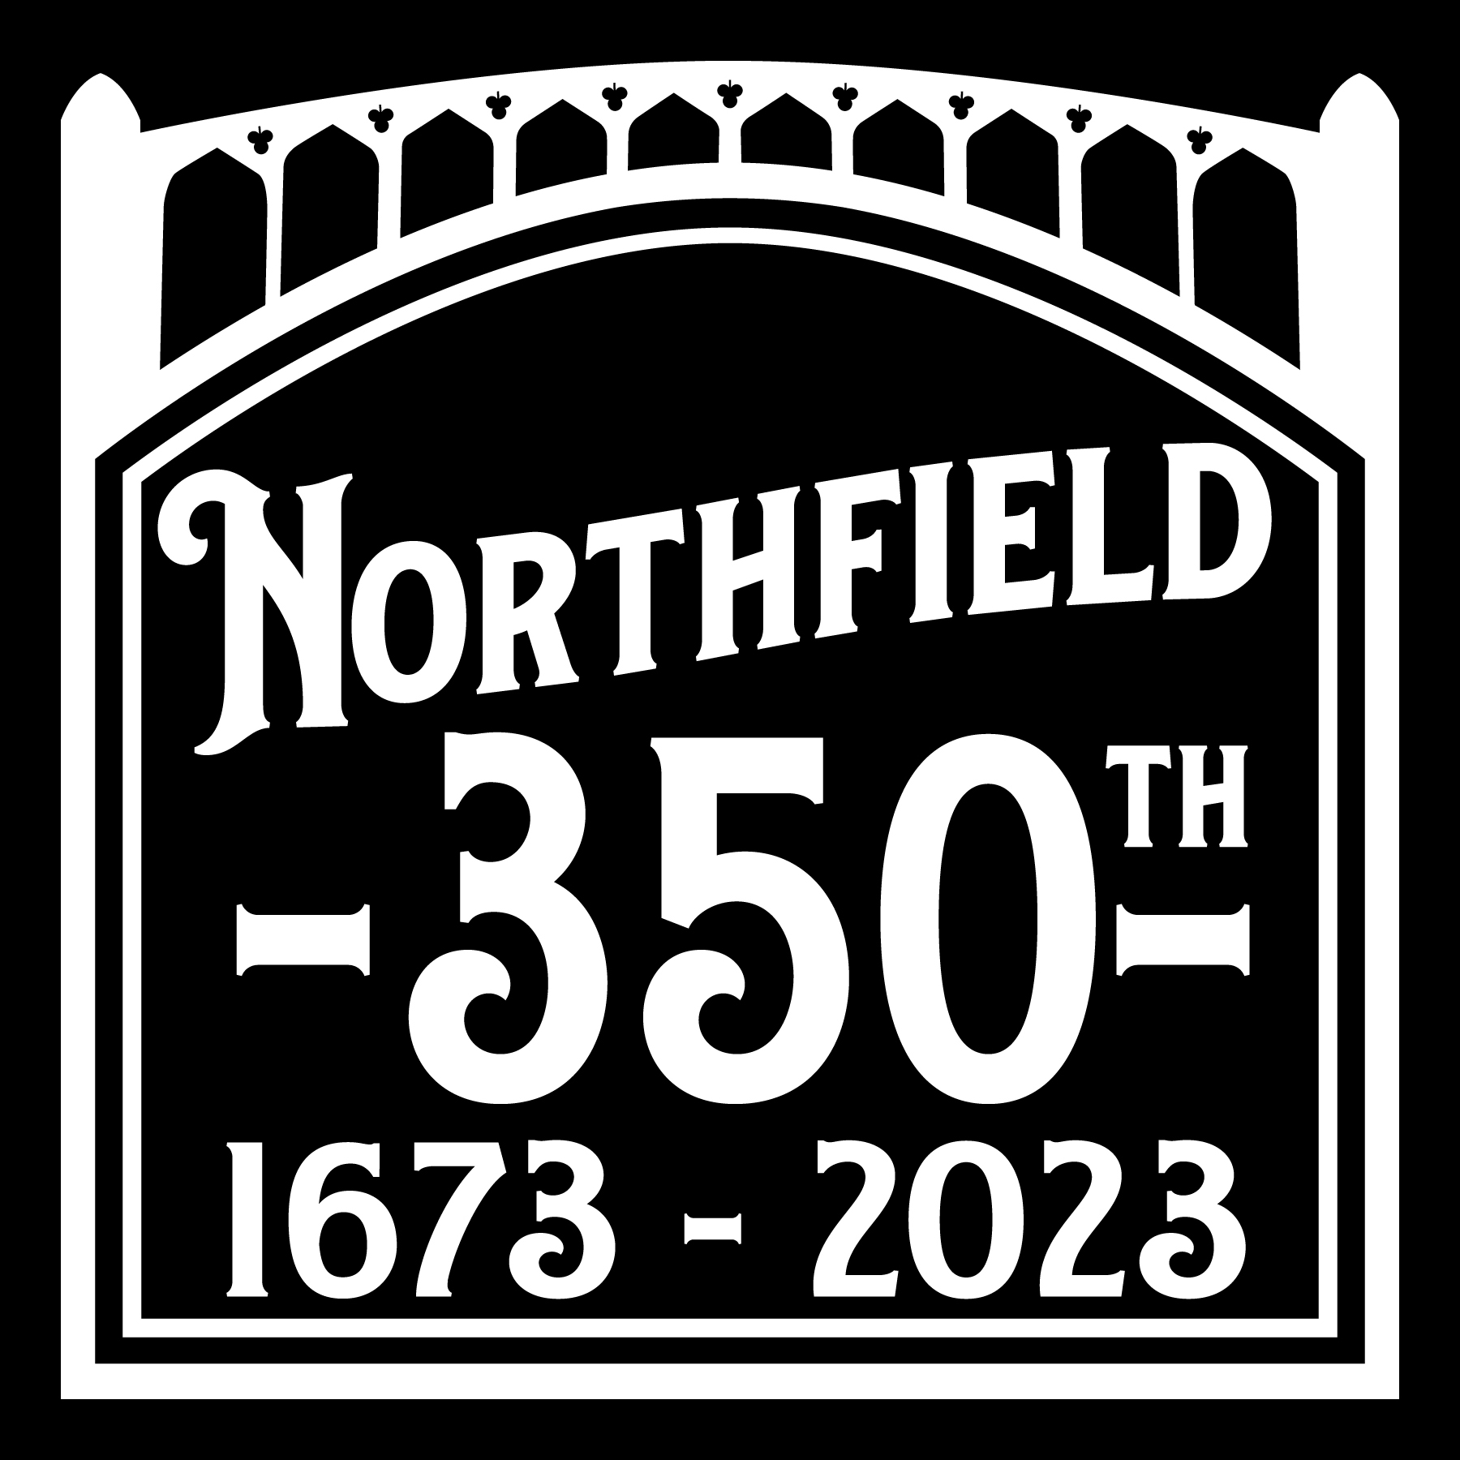
Advertising Partnership Benefits
TOWN OF NORTHFIELD 350TH ANNIVERSARY 2023
Choose the level that meets your advertising or philanthropy goals.

ANNIVERSARY UNDERWRITERS |  |  | EVENT SPONSORS |  | FRIENDS
Advertising Partnership Benefits | Major Underwriter $7,500-5,000 | Contributing Sponsor  $4,000-2,500 | Individual Event  $1,000 | Parade  Sponsor  $1,000 | Business Friend of  The 350th  $500*
Major Underwriter Recognition for ALL Events and Series and in All Print, Broadcast and Electronic Media
Top Banner Position with Logo in Recorder newspaper promotions and on Anniversary website
Mid-Position Acknowledgement in Recorder newspaper promotions and Anniversary website
Listing in Recorder newspaper promotions and Anniversary website
Major Sponsor Acknowledgement in Radio Ads for “Northfield History Minute” and Event promotions
Contributing Sponsor Mentions in Radio Ads for “Northfield History Minute” and Event promotions
Contributing Sponsorship Designation in Individual Events or Series Acknowledge in Promotions
Sponsorship Acknowledgement of One Individual Event in Print and Social Media Promotions
Name and Logo on One “Northfield History” Utility Pole Banner on Main Street/Rt.63
Waived Entry fee for vehicle in the Parade, October 1, 2023
Top Banner Position on Commemorative Posters
Front Placement of Name and Logo on Anniversary Tee Shirts
Back Placement on Anniversary Tee Shirts

NOTES: * Pole Banner availability in the immediate Village Center is limited.

To discuss your options, please contact a member of the Community Engagement Team or call Joan and Steve Stoia at 413-835-1269 or your personal CE Group contact. We are happy to work with you to craft the right package of participation for you.

Thank you,
Town of Northfield 350th Anniversary Committee
Stacy Bond, Chair
69 Main Street, Northfield MA 01360

